An array is a basic data structure to store a collection of elements sequentially. But elements can be accessed randomly since each element in the array can be identified by an array index.

An array can have one or more dimensions. Here we start with the one-dimensional array, which is also called the linear array. Here is an example:

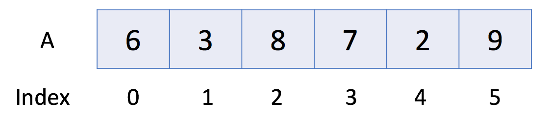

In the above example, there are 6 elements in array A. That is to say, the length of A is 6. We can use A[0] to represent the first element in the array. Therefore, A[0] = 6. Similarly, A[1] = 3, A[2] = 8 and so on.

*Operations in Array*

Let's take a look at the usage of the array.

|  |
| --- |
| // "static void main" must be defined in a public class.  public class Main {  public static void main(String[] args) {  // 1. Initialize  int[] a0 = new int[5];  int[] a1 = {1, 2, 3};  // 2. Get Length  System.out.println("The size of a1 is: " + a1.length);  // 3. Access Element  System.out.println("The first element is: " + a1[0]);  // 4. Iterate all Elements  System.out.print("[Version 1] The contents of a1 are:");  for (int i = 0; i < a1.length; ++i) {  System.out.print(" " + a1[i]);  }  System.out.println();  System.out.print("[Version 2] The contents of a1 are:");  for (int item: a1) {  System.out.print(" " + item);  }  System.out.println();  // 5. Modify Element  a1[0] = 4;  // 6. Sort  Arrays.sort(a1);  }  } |